* 1. **Creating a test case in Tosca Cloud tenant**
     1. Once you are logged into Tosca Cloud tenant, Select the assigned/appropriate Workspace. From the left side navigation pane, select **Build > Test Cases**

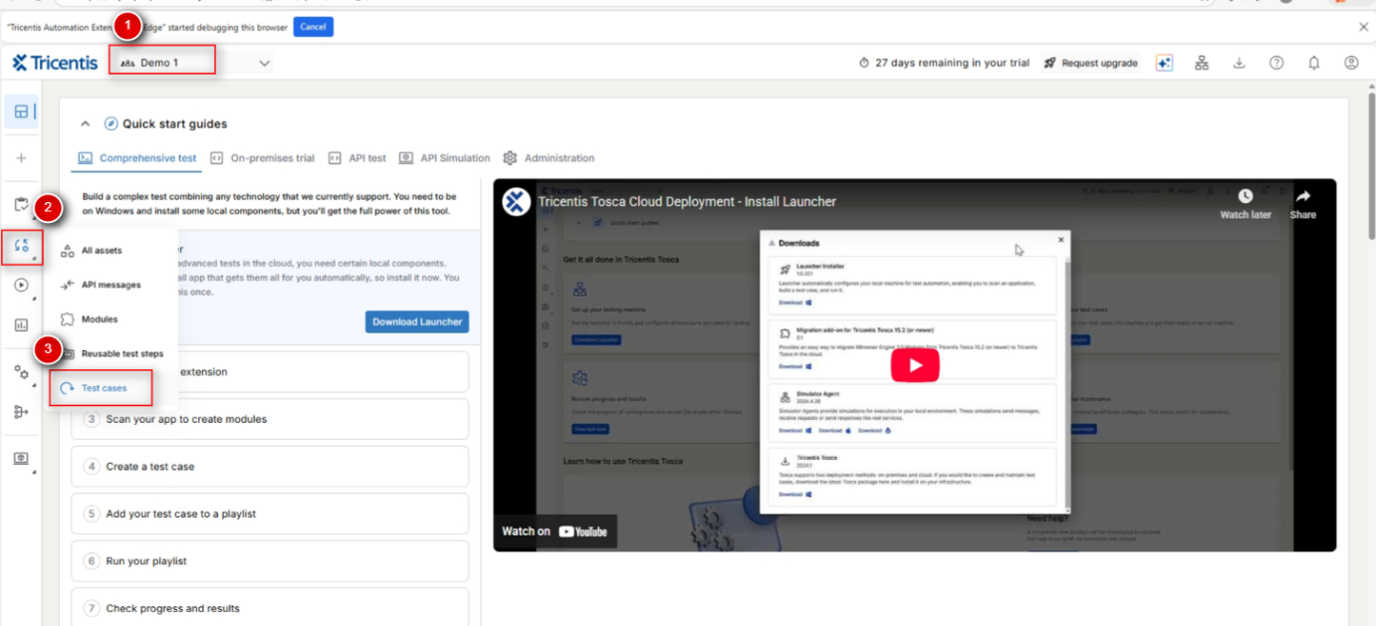

* + 1. Click **Create > Test Case**

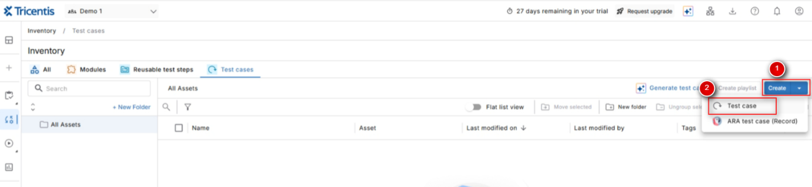

* + 1. Update the name of the test case and **Save**

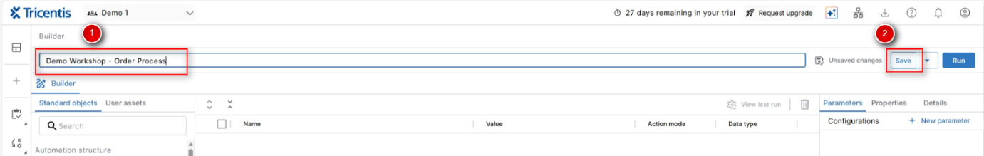

* 1. **Initial Setup of the automated test case**
     1. Create a new parameter to define the browser for execution

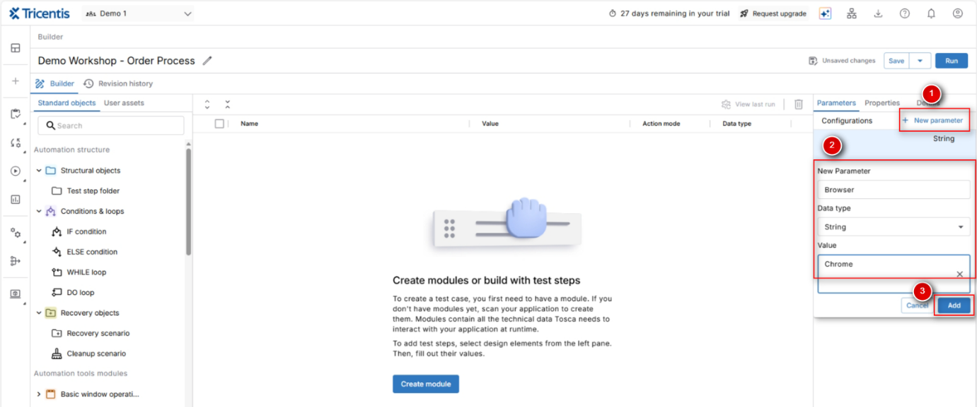

* + 1. Create three folders to have a clear structure of your test case

Precondition *(Contains login flows and prerequisites)*  
Process *(Contains the actual business flow, Validation flow)*  
Postcondition *(Contains post validation steps (Ex: Logout & Close browser))*

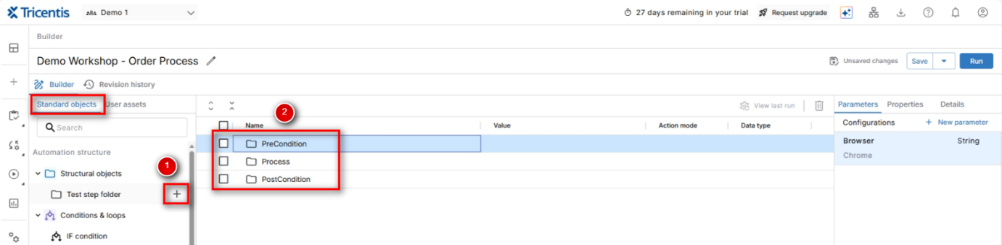

* For CloudALM instructions, start HERE
  1. **Capturing Login screen fields (Demo Web Shop)**
     1. Open [Demo Web Shop](https://demowebshop.tricentis.com/login) application in a new chrome window
     2. You are now prepared for creating your first module. To create, switch to Tosca Cloud tab and select **Create > Create Module** under **User Assets** tab

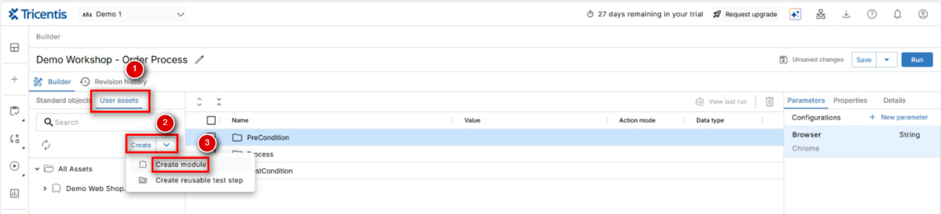

* + 1. If you are accessing for the first time or during any update, Launcher installation screen will appear
    2. Select **Web application** from list and click **‘Start scan’**

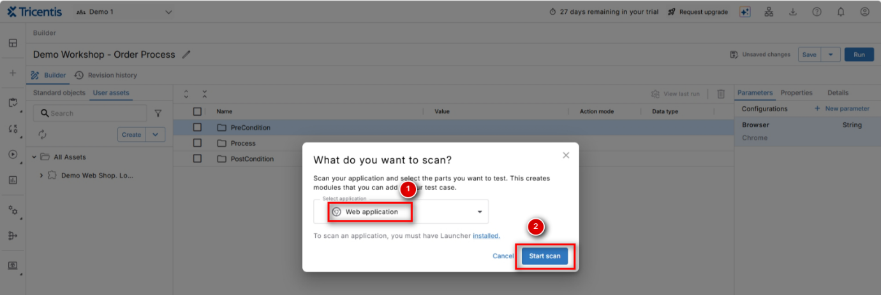

* + 1. In the below screen, check the checkbox and click Open

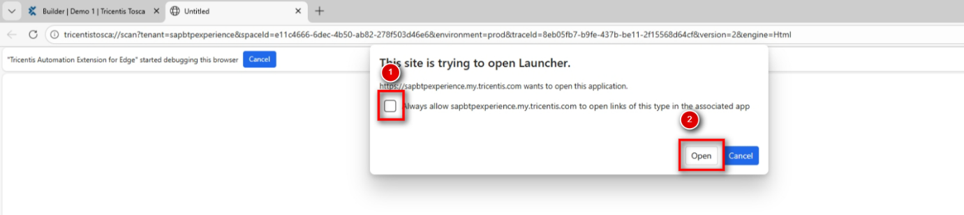

* + 1. The XScan window as shown in the below screenshot appears. Select the browser window that corresponds to Demo Web Shop application and press button **Scan**.

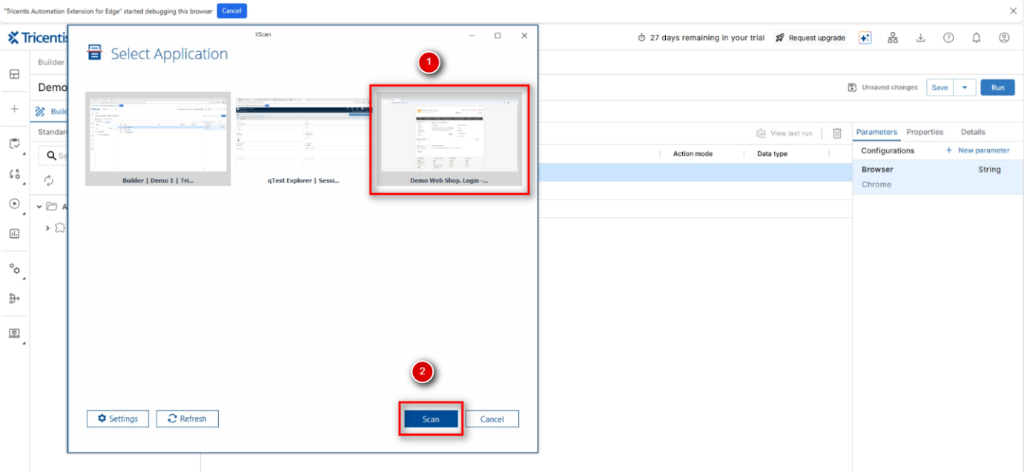

* + 1. The Xscan window will open and allows user to select the required fields from the Demo Web Shop application. Users can switch to Advanced view as well and use **‘Select on Screen’** option to select required fields and, also to view the properties of these fields. Once the required fields are selected, rename the module accordingly so that you can easily find your own module later in the module area

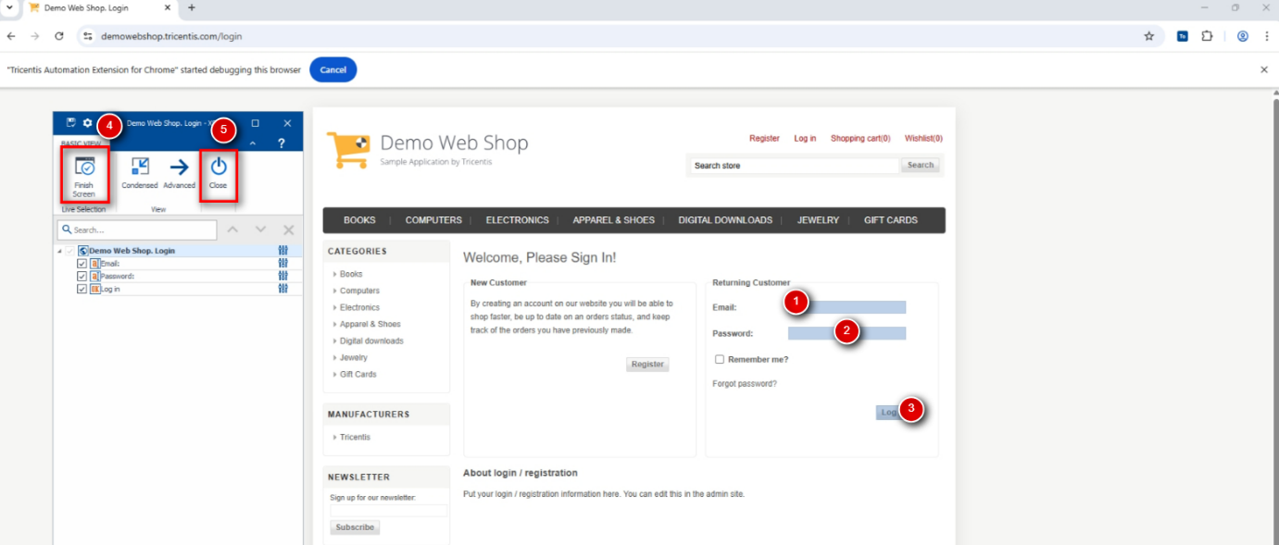

* + 1. Click on **Finish Screen** and close the scanning window
  1. **Creating Login flow as PreCondition**
     1. Switch back to the Tosca Cloud window (with window title - Builder | <Workspacename> | Tricentis Tosca). Under **Standard objects** tab on the left panel, search for **OpenURL**, Hover over the OpenURL module and click on **+** icon next to the module as shown to add it to the test case.

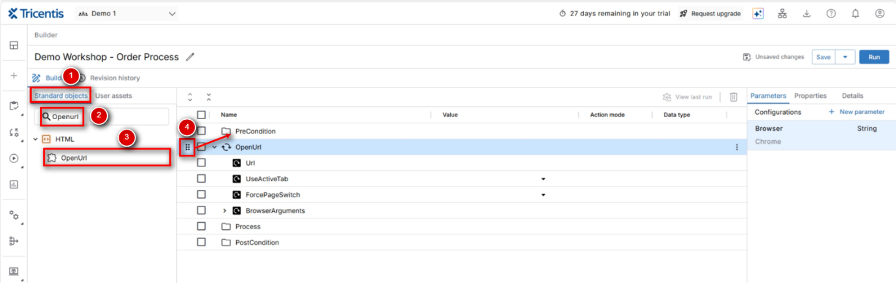

* + 1. Move the step OpenUrl under the folder **PreCondition** and rename it as appropriate (Launch Demo WebShop Application)
    2. Select the test step ‘Launch Demo WebShop Application’ and navigate to **User Assets** tab. Search for your newly created module Demo Web Shop Login. Click on + icon next to the module to add the module as a test step. The test step will be added below the selected test step

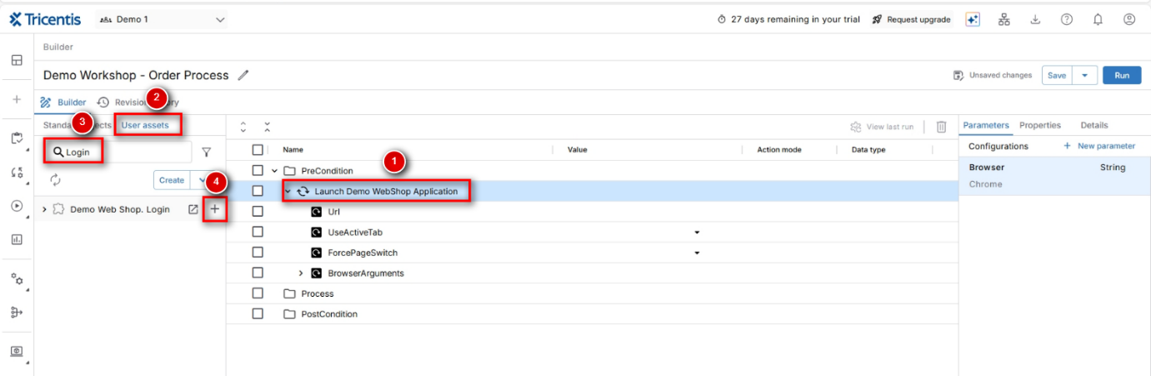

* + 1. Enter the values for URL, Email, Password fields and select ‘{Click}’ as value for the Log in field

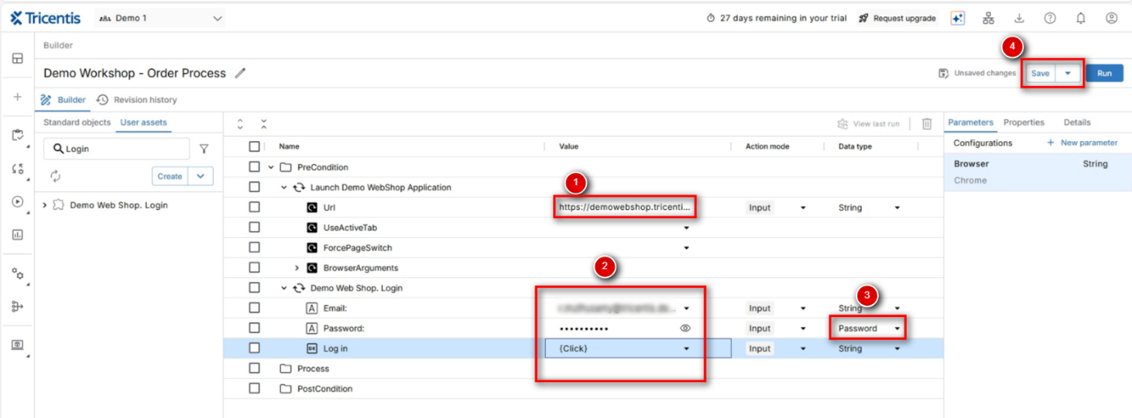

* + 1. Click on Save
    2. Select specifically the login test step and click on button **Run** to run only this step

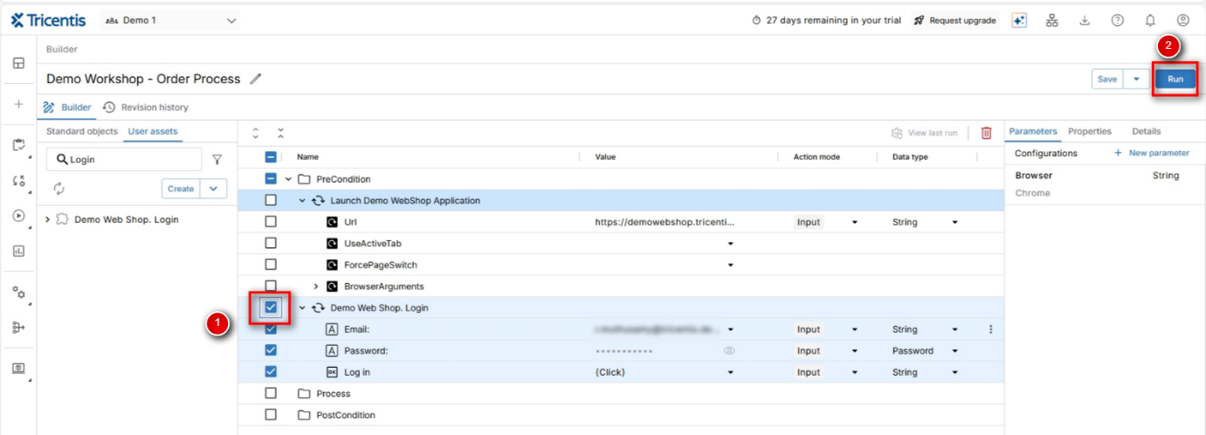

* + 1. After clicking on Run, the personal agent window will appear – minimize this window and **do not click on ‘Close agent’**

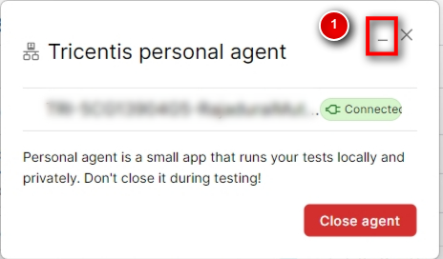

* + 1. Once the login is completed, leave this window open – we are going to build on that.
  1. **Record Steps for Order process**
     1. Switch back to your Builder window in Tosca Cloud and click on the Create Module button, select Web Application, select the Demo Web Shop application and click on Scan (as shown in 1.3.2 – 1.3.6)
     2. Select the following fields on this page

Input Field – Search store

Button – Search

Rename the module as Demo Web Shop – Search Products

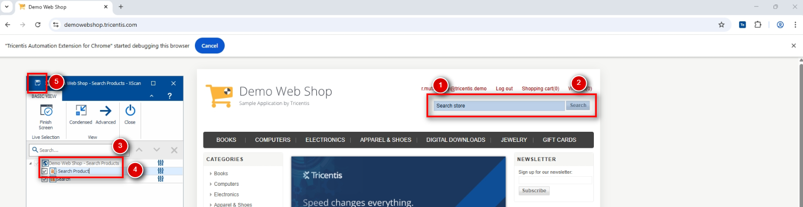

* + 1. Add this module to the test case – click on Process folder, navigate to ‘User assets’ tab and search for the module created in the above step. Click on ‘+’ icon, so that the module is added as a test step in the test case

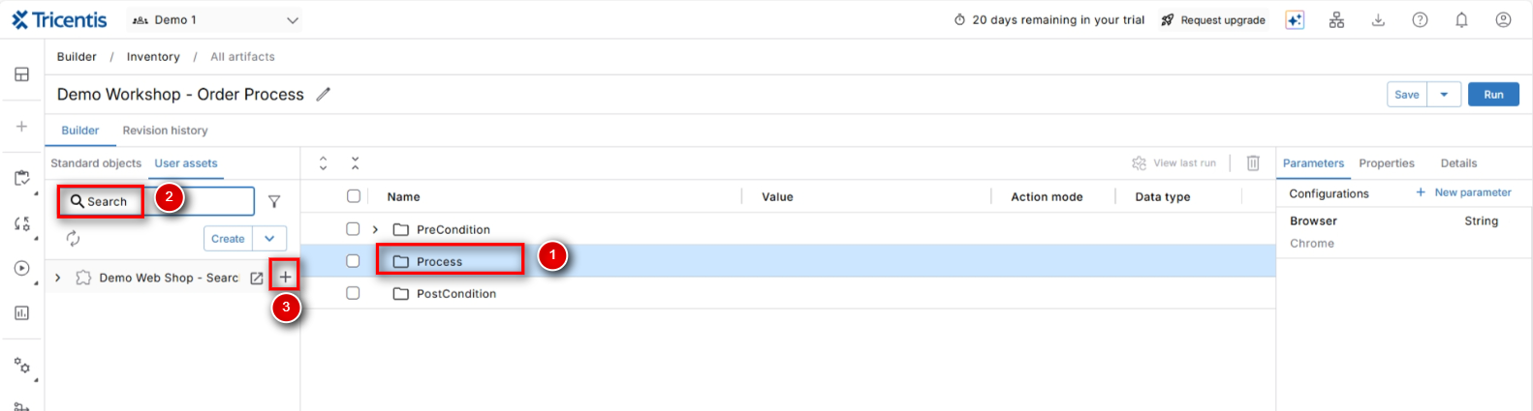

* + 1. Drag and drop the test step so that the test step is under ‘Process’ folder and insert the following values in the test step

Search Product – Laptop

Search – {Click}

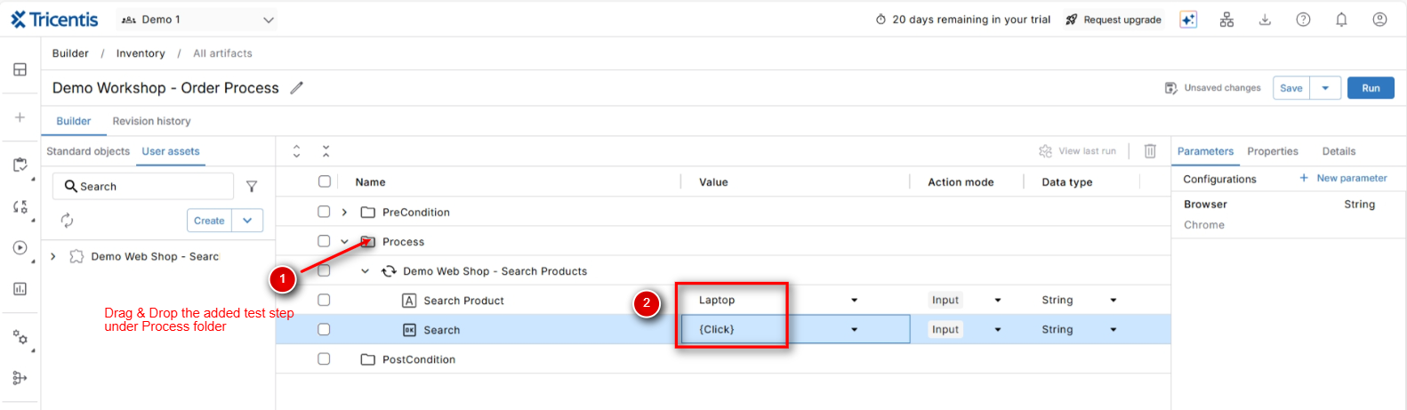

* + 1. Select this step and click on ‘Run’ button (as shown in Step 1.4.6)
    2. Once the run is successful and the next page is loaded, follow the process of creating a new module for the next screen (you know already how it works) – Click Create Module, Select Web Application, Select the Demo Web Shop application browser window, select the controls you need in this page.

14.1-inch Laptop link & Add to cart button. Rename the module as appropriate (Demo Web Shop – Product Details)

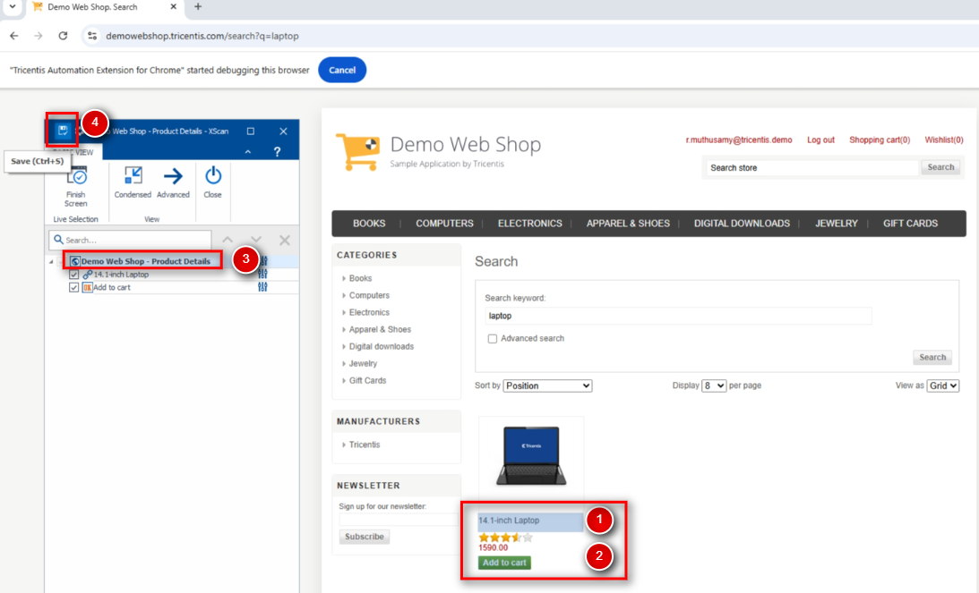

* + 1. Switch back to Builder (Tosca), Add the new module to the test case and insert the following values to the step – Add to cart – {Click}

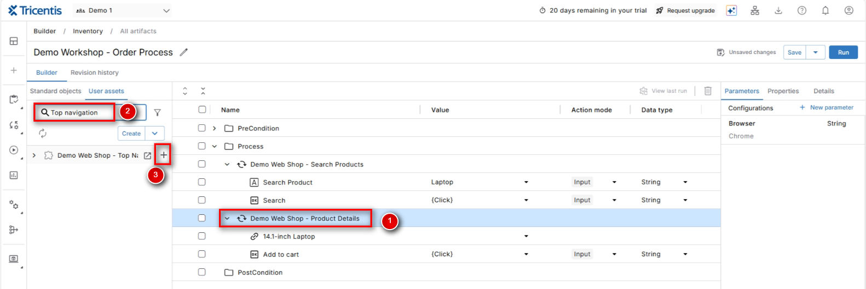

* + 1. Select this step and click on ‘Run’ button (as shown in Step 1.4.6)
    2. Once the run is successful and the next page is loaded, follow the process of creating a new module for the next screen (Shopping cart link)

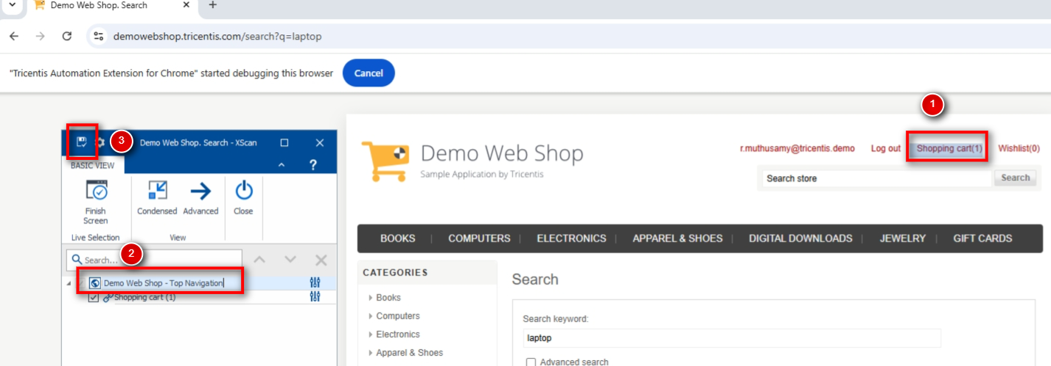

* + 1. Switch back to Builder (Tosca), Add the new module to the test case and insert the following values to the step –Shopping Cart – {Click}

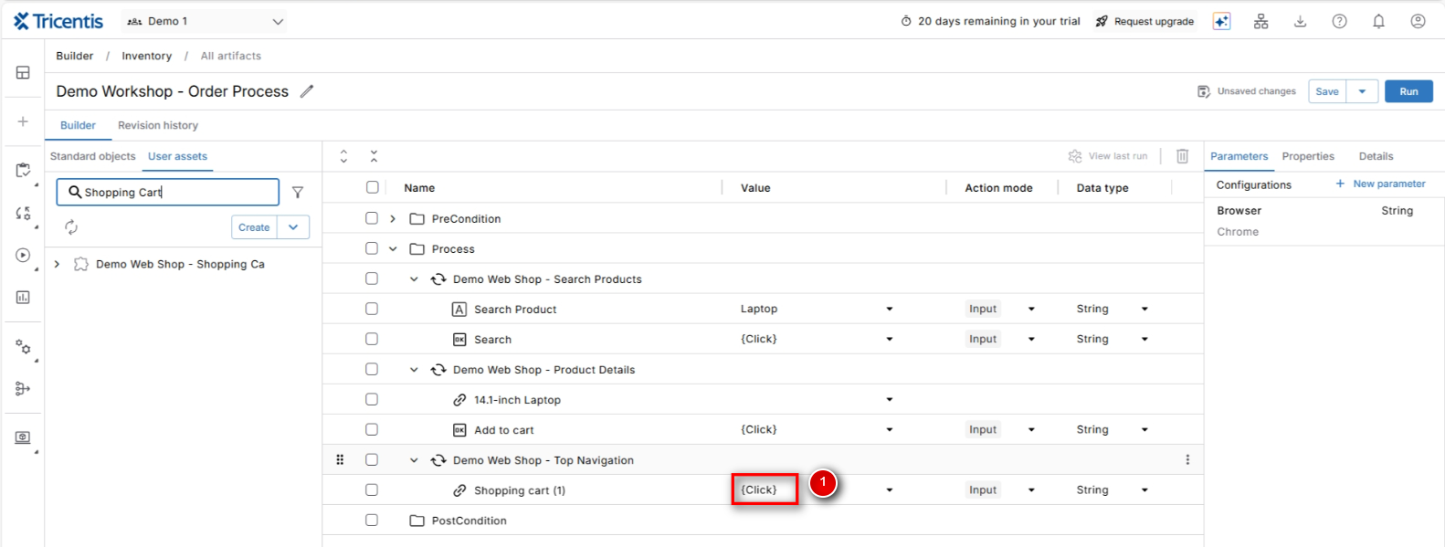

* + 1. Select this step and click on ‘Run’ button (as shown in Step 1.4.6)
    2. Once the run is successful and the next page is loaded, follow the process of creating a new module for the next screen (Terms of Service checkbox and Checkout button).

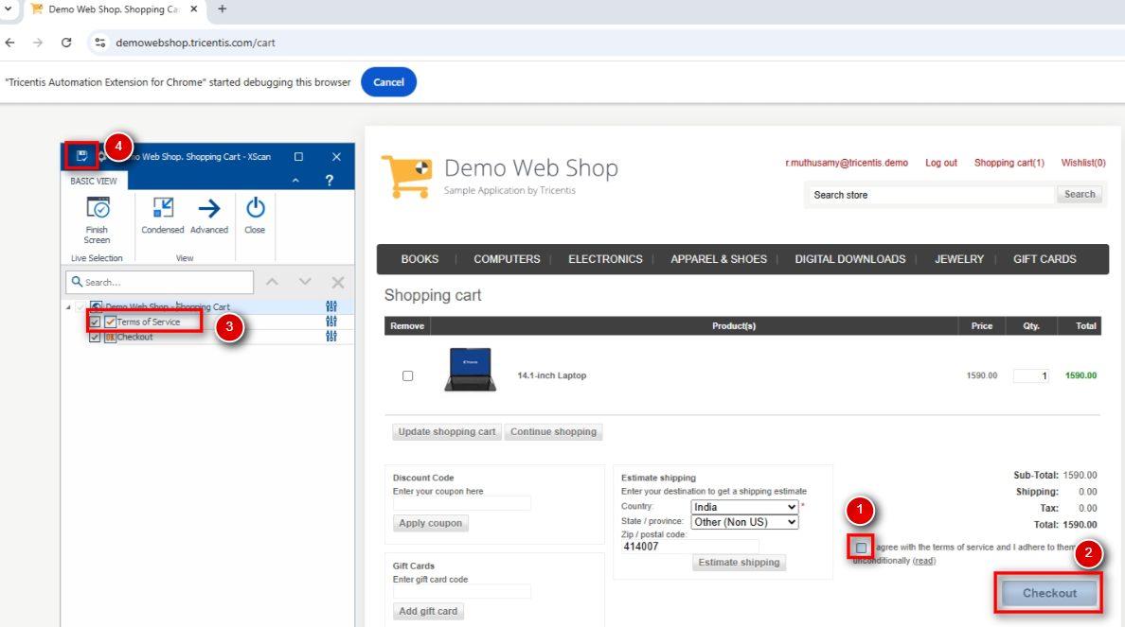

* + 1. Switch back to Builder (Tosca), Add the new module to the test case and insert the following values to the step –Shopping Cart – {Click}

Terms of Service – True

Checkout – {Click}

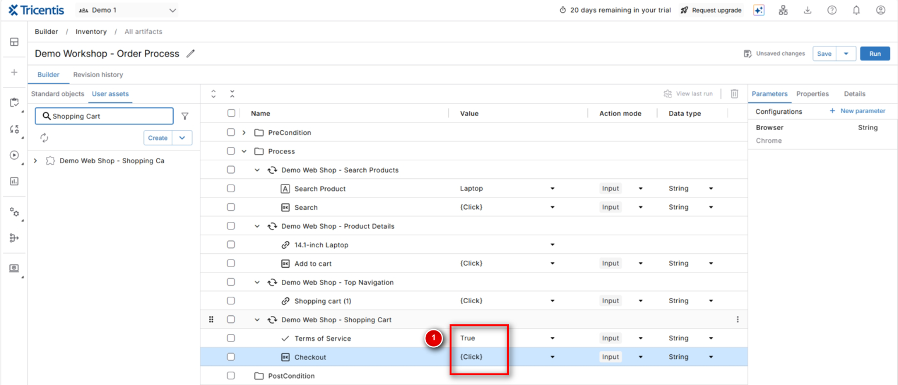

* + 1. Select this step and click on ‘Run’ button (as shown in Step 1.4.6)
    2. Once the run is successful and the next page is loaded, follow the process of creating a new module for the next screen (Continue button)

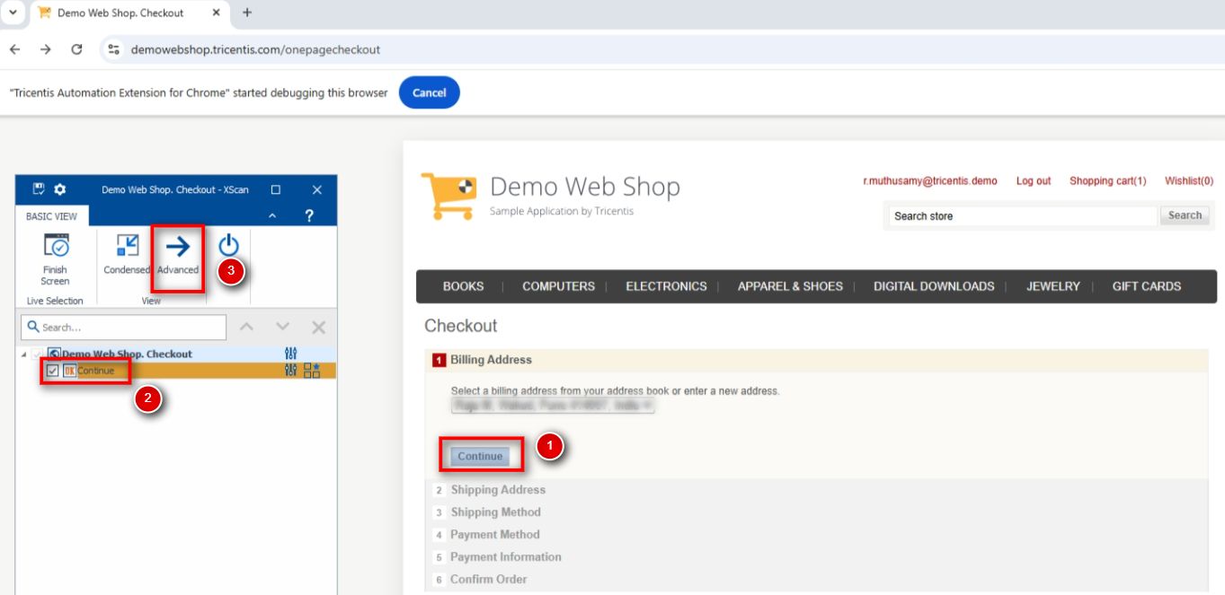

* + 1. In this module, the module attribute (the Continue button we have just added) is highlighted in Orange indicating that Tosca is not able to identify this button. Select the button and click on **Advanced.** In the next screen, select (check the checkbox) next to Visible property

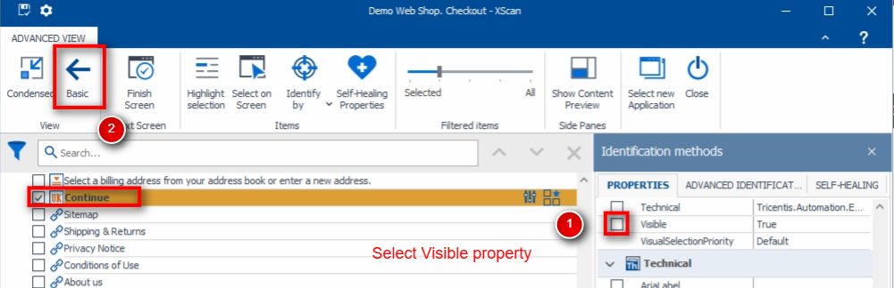

* + 1. Once this property is added, the control should not be highlighted in Orange colour. Go back to Basic window, save the module, finish and close the xscan window.

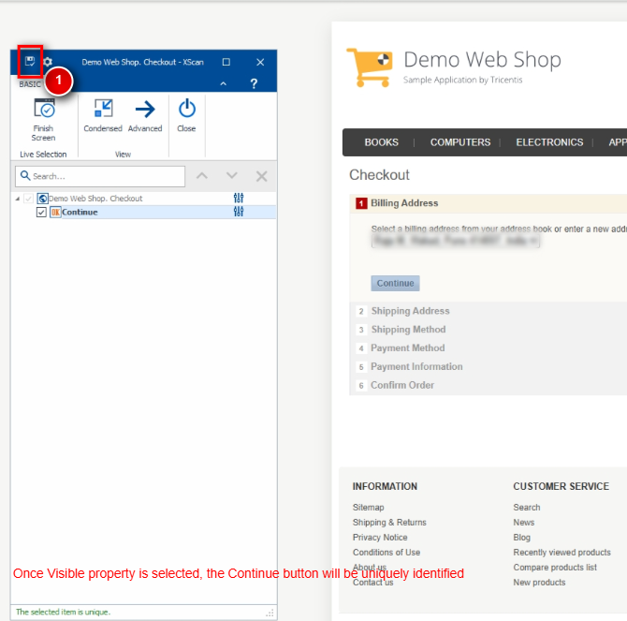

* + 1. Switch back to Builder (Tosca), Add the new module to the test case

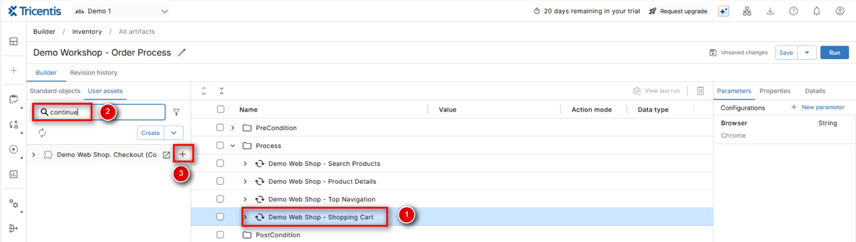

* + 1. Insert the following values to the step – Continue – {Click}

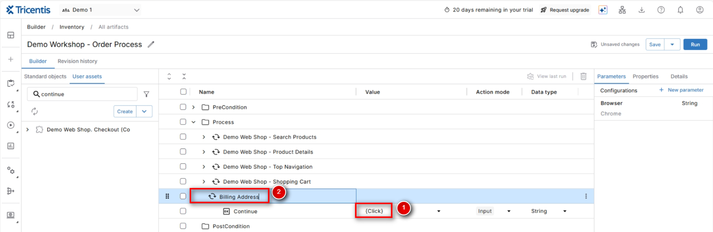

* + 1. Select this step and click on ‘Run’ button (as shown in Step 1.4.6)
    2. - Repeat above 6 steps (1.5.15 - 1.5.20) 4 more times to click Continue for Shipping Address, Shipping Method, Payment Method & Payment Information

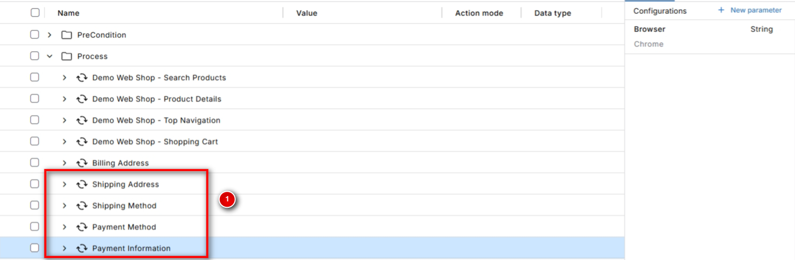

* + 1. Once the run is successful and the next page is loaded, follow the process of creating a new module for the next screen (Continue button)

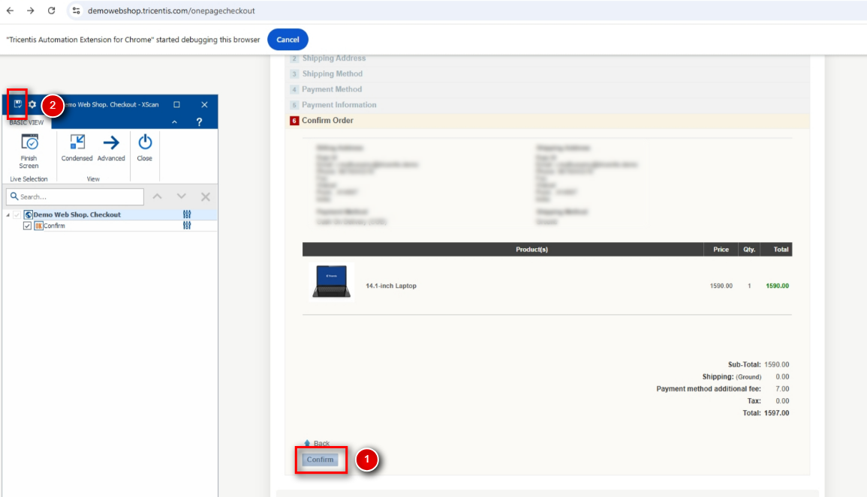

* + 1. Switch back to Builder (Tosca), Add the new module to the test case and insert the following values to the step –Confirm – {Click}
    2. Select this step and click on ‘Run’ button (as shown in Step 1.4.6)
    3. Once the run is successful and the next page is loaded, follow the process of creating a new module for the next screen (Success message, Order Number, Continue button and the container of all these 3 fields)

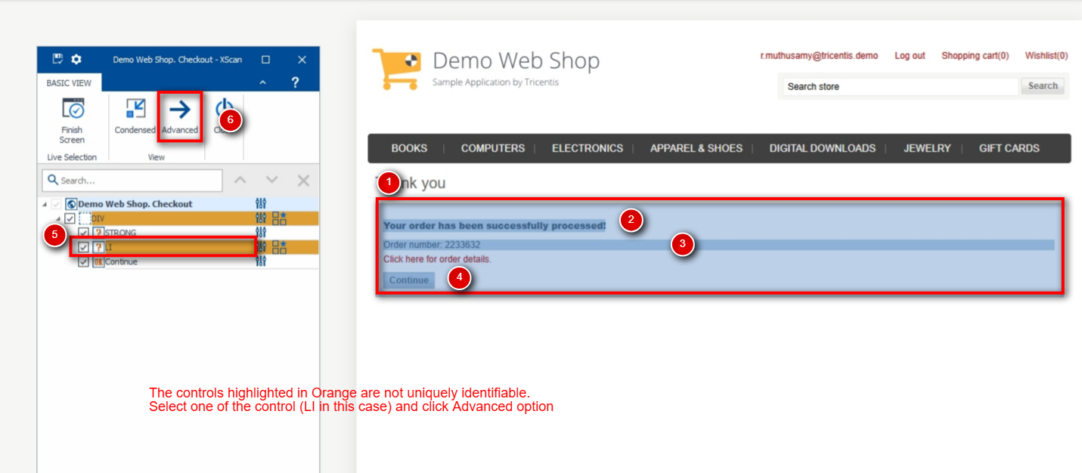

* + 1. Like step 1.5.16, in this module, the 2 module attributes (the order number text and container) are highlighted in Orange indicating that Tosca cannot identify these controls with the default properties. Select one of the controls (the order number text) and click on **Advanced.** In the next screen, select (check the checkbox) next to ‘OuterText’ property and change the value to not reflect the order number (as it will keep changing every time) – Order number: *
    2. Once this property is selected, the control should no longer be highlighted in Orange

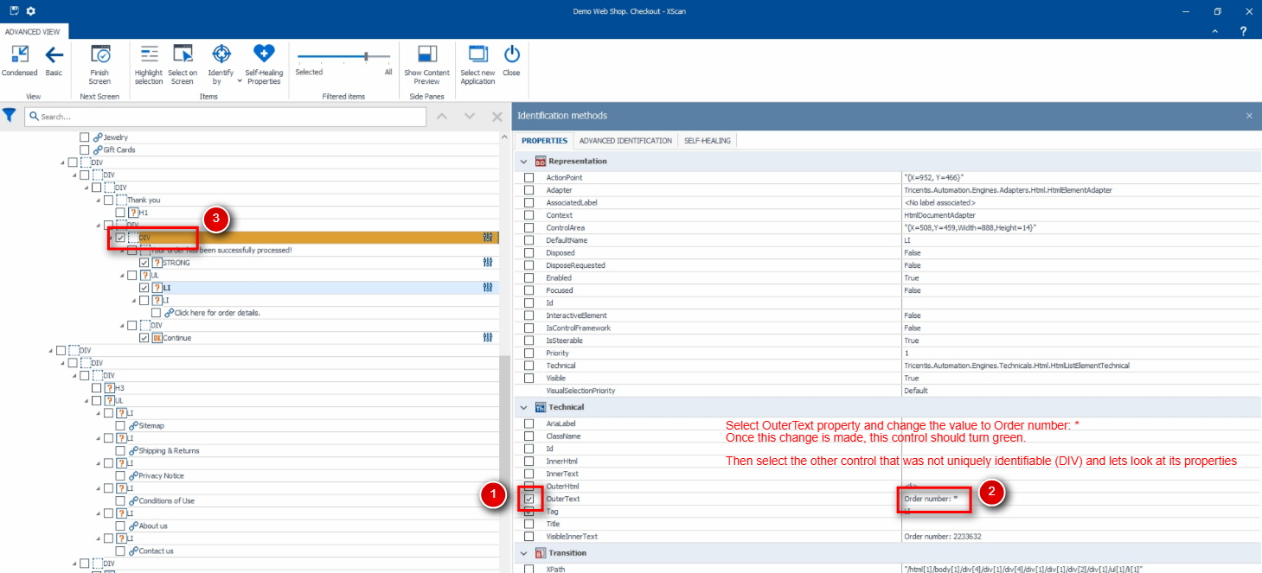

* + 1. Now select the other control that is being highlighted in Orange and update the properties as shown in the screenshot

Unselect ‘InnerText’ property

Select ‘ClassName’ property

* + 1. Once these properties are selected, the control should no longer be highlighted in Orange

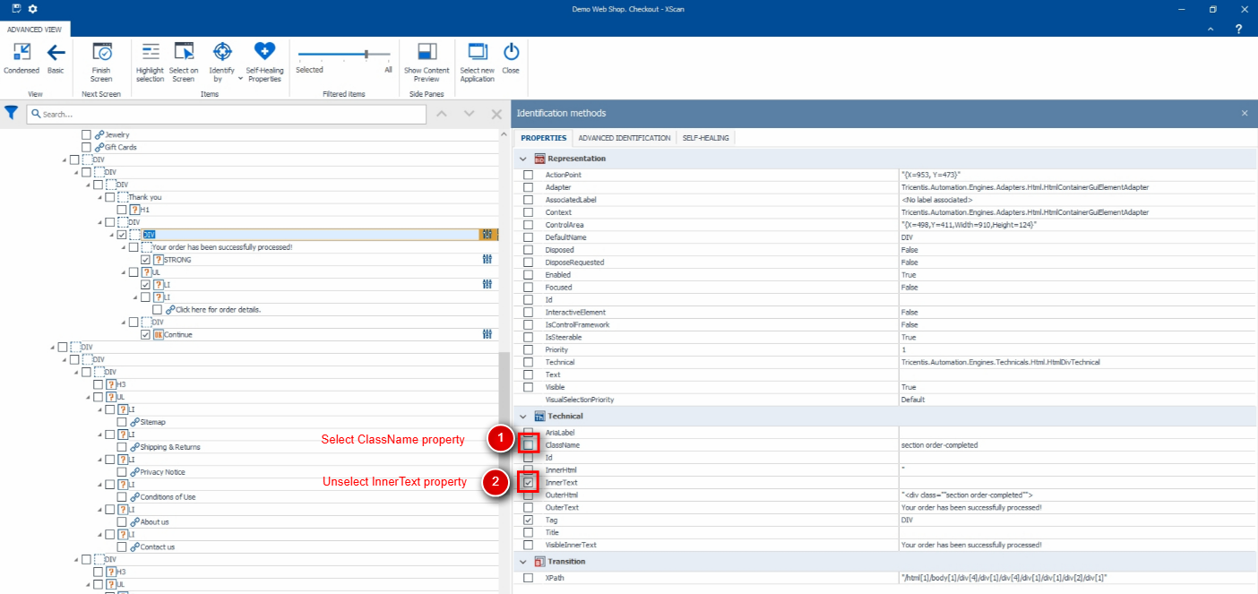

* + 1. – Update the name of the controls to something meaningful, save and close the xscan window

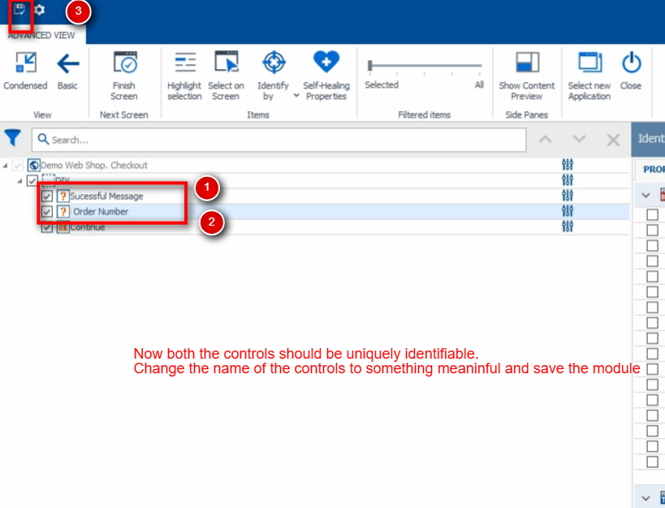

* + 1. Switch back to Builder (Tosca), Add the new module to the test case

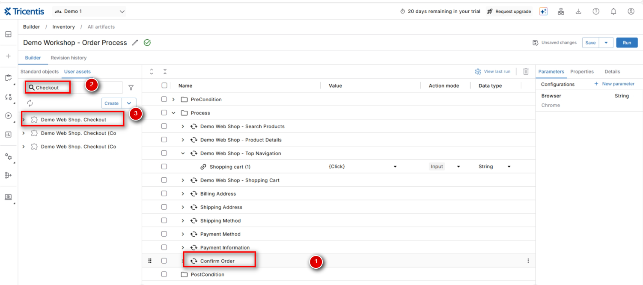

* + 1. Select the 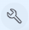 icon next to Order Number field and apply the values as shown below

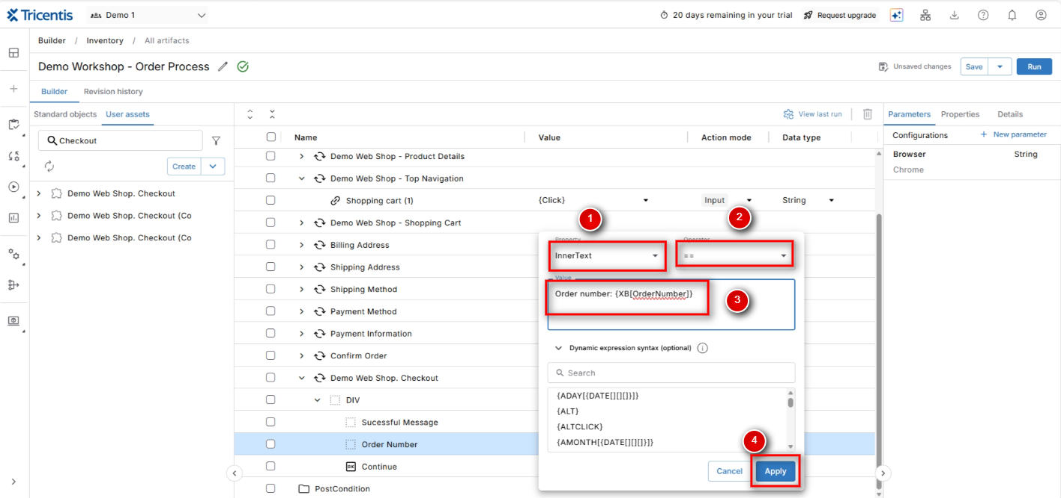

* + 1. Set the action mode to verify

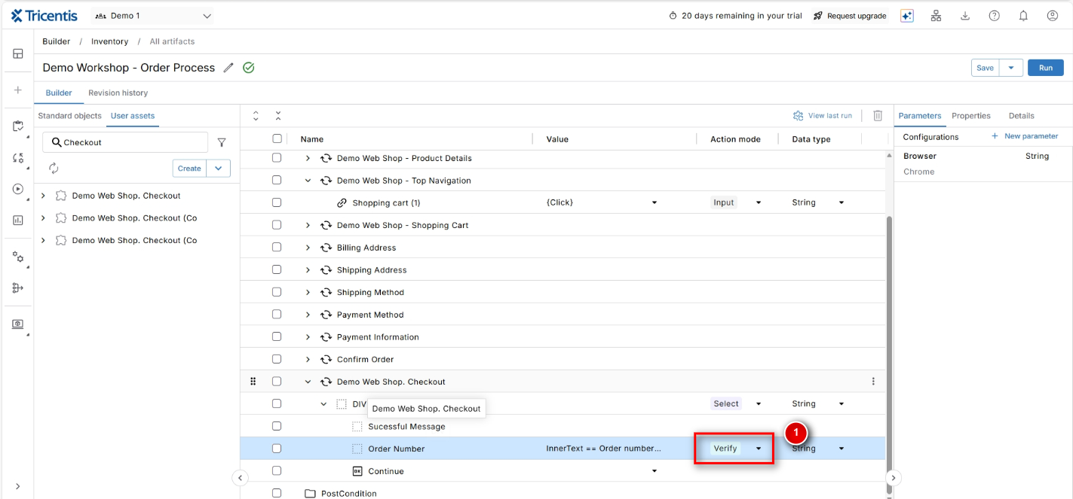

* + 1. Select this step and click on ‘Run’ button (as shown in Step 1.4.6). The order number should be stored within Tosca for further reference.
    2. Update the test step names and try now for a complete run (close the Demo Web Shop window before running the test case). Are you getting the sync error while navigating the pages? The next exercise will solve that.

